**Introduction to Python Programming language**

**Lab report #02 & 03**



Fall 2022

CSE-408L Data Analytics

Submitted by: **Ashfaq Ahmad**

Registration No: **19PWCSE1795**

Class Section: **B**

“On my honor, as student of University of Engineering and Technology, I have neither given nor received unauthorized assistance on this academic work.”

Student Signature: ______________

Submitted to:

**Eng: Faizullah**

**Nov 01**, 2022

**Department of Computer Systems Engineering**

**University of Engineering and Technology, Peshawar**

**Task 01:** Take two numbers from the user and perform different mathematical operations on them using Python programming language.

**Source Code:**

import math

import random

num1=int(input('Enter num1:')) #input num1

num2=int(input("Enter num2:")) #input num2

#addition

add=num1+num2

print("sum of num1 and num2=",add)

#subtraction

sub=num1-num2

print("subtraction of num1 and num2=",sub)

#Multiplication

mul=num1*num2  #we can also call math.pow function.

print("Multiplication of num1 and num2=",mul)

#Division

div=num1/num2

print("Multiplication of num1 and num2=",div)

#modulus

mod=num1%num2

print("modulus=",mod)

#power

pw=num1**num2

print("num1 power num2=",pw)

#max

m=max(num1,num2)

print("max of num1 & num2=",m)

#min

mi=min(num1,num2)

print("min of num1 & num2=",mi)

#square1

sq1=math.sqrt(num1)

print("square root of num1=",sq1)

#square2

sq2=math.sqrt(num2)

print("square root of num2=",sq2)

#log 1

lg1=math.log(num1)

print("log of num1=",lg1)

#log 2

lg2=math.log(num2)

print("log of num2=",lg2)

#sine1

s1=math.sin(num1)

print("sine of num1=",s1)

#sine2

s2=math.sin(num2)

print("sine of num2=",s2)

#cosine1

c1=math.cos(num1)

print("cosine of num1=",c1)

#cosine2

c2=math.cos(num2)

print("cosine of num2=",c2)

#Tangent1

T1=math.tan(num1)

print("Tangent of num1=",T1)

#Tangent2

T2=math.tan(num2)

print("Tangent of num2=",T2)

#arc sine 1             (value of input to asin, atan, acos must b/w -1 and 1)

si1=math.asin(s1)

print("arc sine of num1=",si1)

#sarc sine 2

si2=math.asin(s2)

print("arc sine of num2=",si2)

#arc cosine 1

ci1=math.acos(c1)

print("arc cosine of num1=",ci1)

#arc cosine 2

ci2=math.acos(c2)

print("arc cosine of num2=",ci2)

#arc tangent 1

Ti1=math.atan(T1)

print("arc tangent of num1=",Ti1)

#arc tangent 2

Ti2=math.atan(T2)

print("arc tangent of num2=",Ti2)

#concatenation

concat=str(num1)+str(num2)

print("concatenation of num1 and num2: ",concat)

#random

R=random.randrange(num1,num2)

print("random value between num1 and num2: ",R)

**Output:**

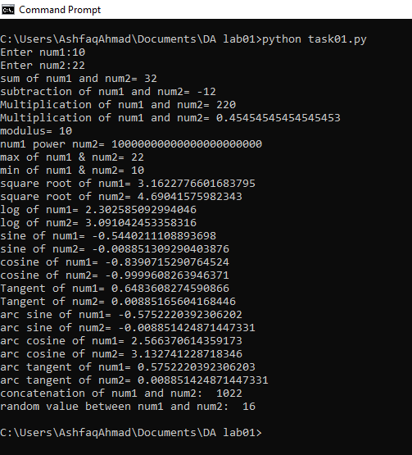

**Task02:** Display a randomly generated number between two numbers entered by the user.

**Source Code:**

import random

num1=int(input("Please enter Num1: "))

num2=int(input("Please enter Num2: "))

z=random.randrange(num1,num2)

print("The ranom value between two entered values is: ",z)

**Output:**

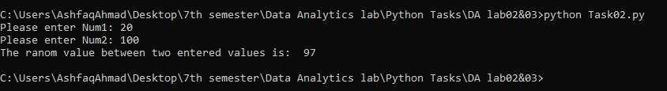

**Task03:** Generate a 3 digits number randomly and display sum of the digits of that number.

**Source Code:**

import random

num1=int(input("Please enter Num1: "))

num2=int(input("Please enter Num2: "))

z=random.randrange(num1,num2)

print("The ranom 3 digits value between two entered values is: ",z)

s=str(z)

result=int(s[0])+int(s[1])+int(s[2])

print("The sum of these 3 digits is: ",result)

**Output:**

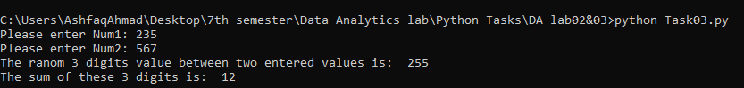

**Task 04:** Take radius of the orbit in million km and orbital speed in km/s from the user. Calculate the duration of year on the planet and display the output to the user on console.

**Source Code:**

from cmath import pi

import math

Redius=int(input("Please enter the redius of an Orbit in Million Km: "))

Velocity=int(input("Please enter the orbital speed in Km/s: "))

duration=(2*pi*Redius)/Velocity

print("The duration of Year in second on planet is: ",duration)

**Output:**

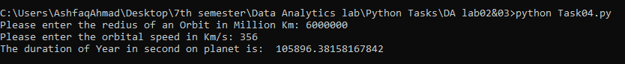

**Task05:** Take the temperature in Celsius from user and display the output in Fahrenheit.

**Source Code:**

c=int(input("Please! Enter tempersture in Celcius: "))

f=c*(9/5)+32

print("The temperature in Fahrenheit: ",f)

**Output:**



**Task06:** how would you update a tuple on run time?

**Source Code:**

x=(34,"ashfaq",45, 68,"Ahmad")

print(x)

i=int(input("Please enter the index at which you want to update an element: "))

if i>len(x):

    print("Sorry your index is out of range.")

u=input("Please enter updated elemet: ")

y=list(x)     #'tuple' object does not support item assignment

y[i]=u

x=tuple(y);

print("Now the Updated tuple is: ",x)

**Output:**

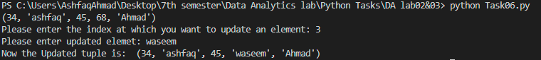

**Task07:** Take 10 numbers from the user. Store these numbers in a list. Find the number which is most often in the list and print it on the console.

**Source Code:**

lst=[int(input("Please enter number: " )) for x in range(10)]

print("list is: ",lst )

lst_1=[(lst.count(x),x) for x in set(lst)]

#extract the frequency from the tuple(freq,ele)

max_count=max(lst_1)[0]

#print the element if the frequency is equal to maximum count

for ele in lst_1:

   if ele[0]==max_count:

       print("The Most often element in list is : ",ele[1])

**Output:**

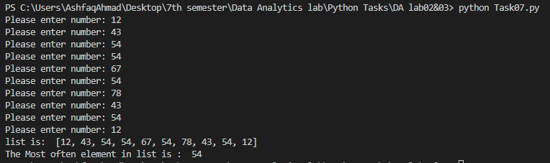

**Task08:** Take two lists from user of same length. Create a dictionary from those two lists. Print on the console both lists and the created dictionary.

**Source Code:**

lst1=[input("Please Enter list 1 element: ") for i in range(5)]

lst2=[int(input("Please Enter list 2 element: ")) for i in range(5)]

print("List 1 is :",lst1)

print("List 1 is :",lst2)

dictnry={lst1[i]:lst2[i] for i in range(len(lst1))}

print("The resultent Dictionary is: ",dictnry)

**Output:**

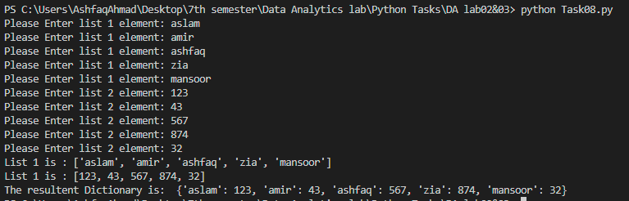

**The End**